SOA EXPERIMENT-4
TITLE:- Token-Based Authentication for Banking API

Step 1: Create the Spring Boot Project
- Open Eclipse IDE.
- Create a Spring Boot project named SOA_banking-api.
- Select Java 17.
- Select Maven as the build tool.
- Add the required dependencies:
  - Spring Web
  - Spring Security
- Create the project.
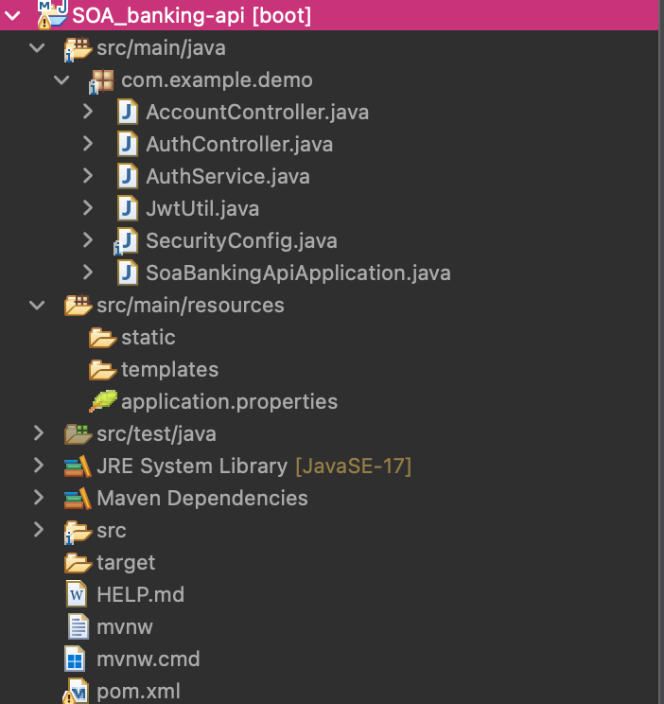

STEP-2:- CONFIGURE POM.XML
-> OPEN Pom.xml
->Add the JJWT dependencies required for JWT authentication.
->Save the file.
->Update the Maven project.
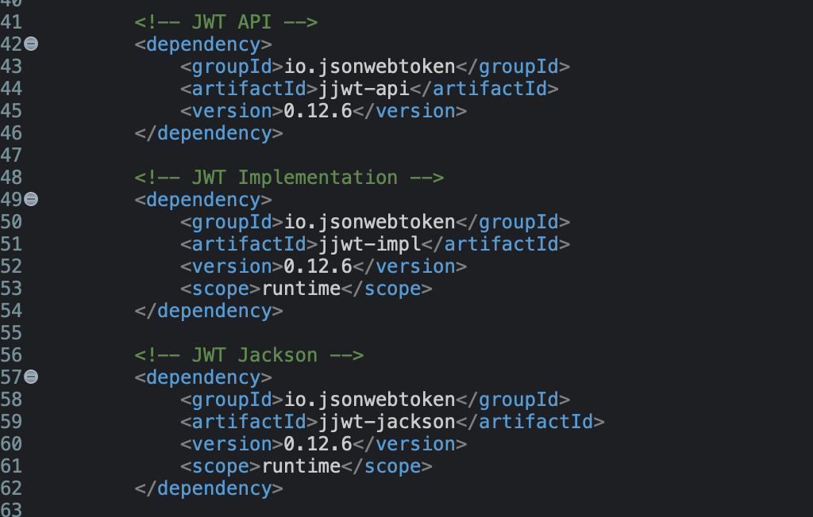

STEP-3:- CREATE JWTUTIL.JAVA
->OPEN jwtutil.java
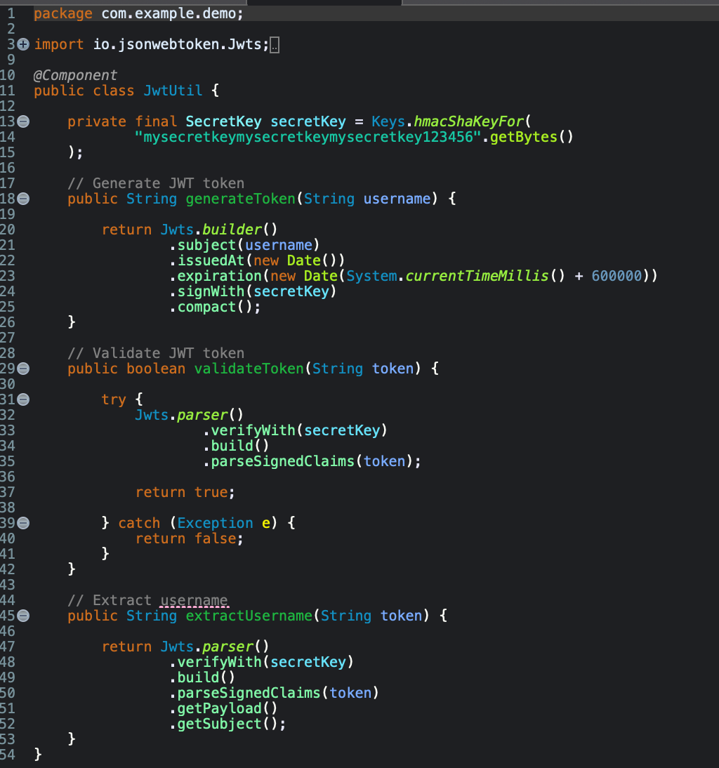

STEP-4:- CREATE AUTHSERVICE.JAVA
->Open AuthService.java
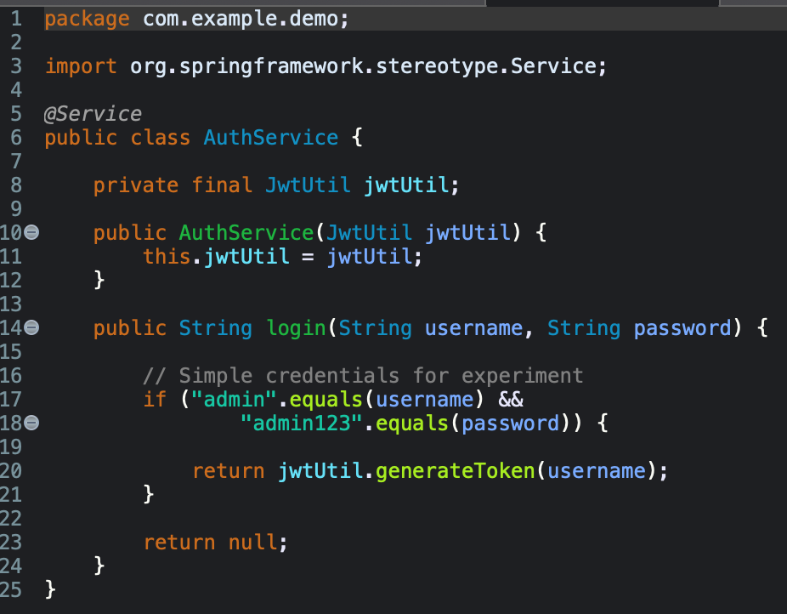

STEP-5:- CREATE AUTHCONTROLLER.JAVA
->open authcontroller.java
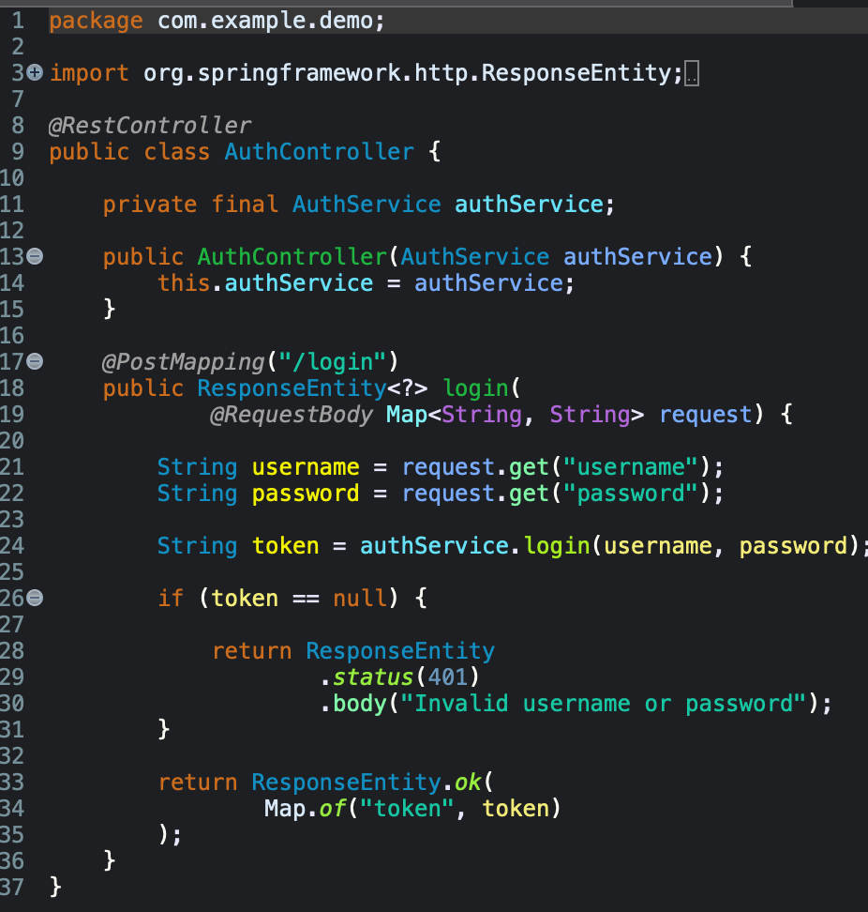
STEP-6:- CONFIGURE SPRING SECURITY
->open securityconfig.java
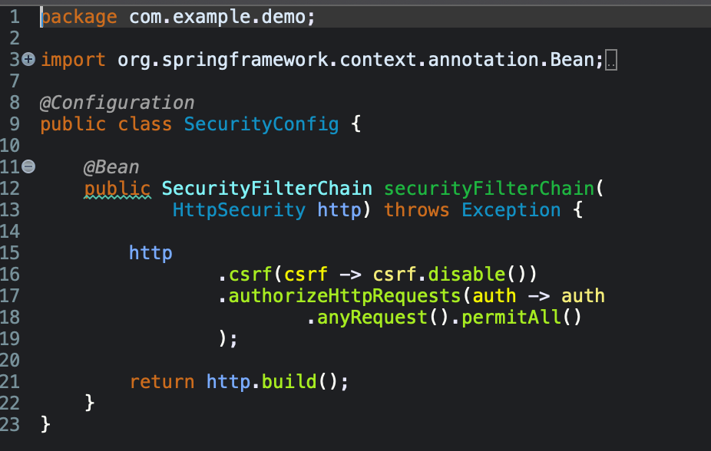
STEP-7:- CONFIGURE APPLICATION PROPERTIES
-> OPEN src/main/resources/application.properties
-> add:-
spring.application.name=SOA-banking-api
server.port=8082
->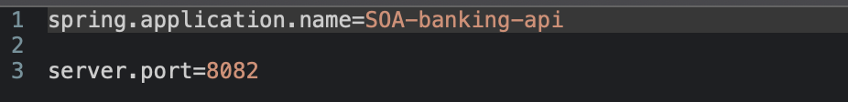

STEP-8:- RUN THE APPLICATION
-> right-click SoaBankingApiApplication.java.
->select:-
Run As → Spring Boot App
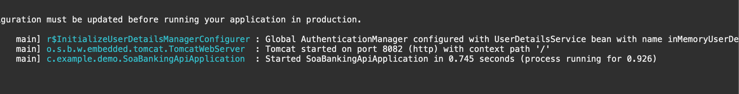

STEP-9:- OPEN POSTMAN
-> select POST
-> URL:- http://localhost:8082/login
-> Select:- Body → raw → JSON
-> enter:- {
"username": "admin",
"password": "admin123"
}
->OUTPUT:-
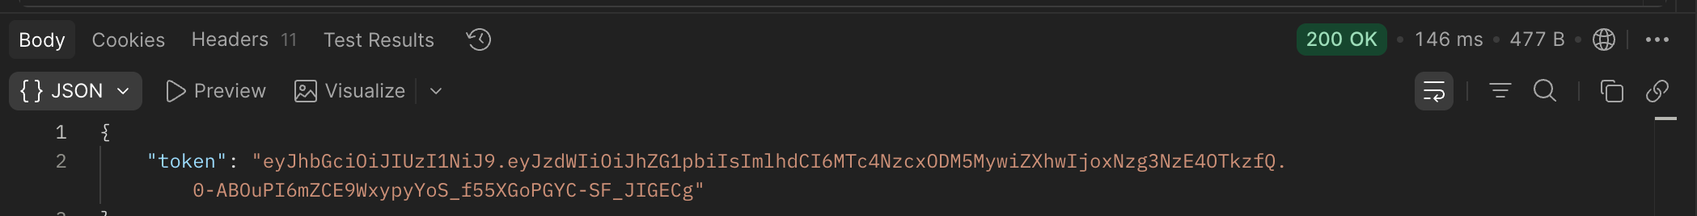

->select GET
->URL:- http://localhost:8082/account/details
->Go to headers
-> add:-
Key: Authorization
Value: Bearer <JWT_TOKEN>
->click send
->OUTPUT:- Account Details for admin: Balance = ₹50,000

